**Goutam Debnath**

**goutamd2@illinois.edu**

**CS-416 Summer 2024**

**Submission for Week 9 Narrative Visualization:**

# Topic: A Study on Health, Economic, Psychological and Social cost of Air pollution.

URL: <https://goutamdebnath.github.io/cs416-airpollution-storytelling/>

The story telling form of this narrative visualization is based on the Martini Glass structure. The story has been structured into 4 scenes anchored around the question and information on the effect of air pollution since very early days of industrial development.

**Messaging:**

The messaging conveyed in the visualization is how technology and government policies around the world are helping to bring down the air pollution.

The message is conveyed to the reader from the eye of the author telling the current health and mortality caused and progresses to its affect and hazards and concluding by giving charts and details of research on how the major part of the pollution has been kept under control in last 30 years.

**Narrative Structure:**

The narrative structure follows the Martini Glass style of visualization.

1. The narration starts where the author makes its readers aware if the situation of human life losses due to air pollution and presents the basic data to tell that air pollution causes top 3 death reason.
2. The author then lets the user navigate to tell a little history of various causes of CO2 air pollution in a year wise timeline and the advent of usage of various fossil fuels contributed to CO2 emission.
3. When the reader navigates to the next scene, the reader is presented with other impacts of the air pollution which we all should be aware of.
4. Finally the narration concludes by showing how government policies and technological breakthrough across the world is helping reduce the air pollution of different other components.

**Visual Structure:**

The visual structure in building each scene includes, simple charts with data, visual highlights in bold colors, animating circles, glowing pointers, navigation buttons, tooltip info and chart headers and side navigation bars to jump around in the story scene.

**Below are the visual elements of the slides**

Figure 1 Various visual elements

**Consistent visualizations and page look and feel** (Links on Left side of the page as well as the arrows on the right side of the diagram can be used for navigation between pages)

Figure 2 Consistent Look and feel

**The concluding scene showing visual cues of downward trend**

* Links on Left side of the page as well as the arrow on the right side of the diagram can be used for navigation between pages
* Please note the Tooltip balloons for additional details for a specific data point
* External link is provided for Air quality Trends. As we can see the data indicates *Downward Trends* for harmful emissions

Figure 3 Trend analysis

**Scenes:**

The scenes are ordered such that a storytelling is followed by a questionnaire of what, how, when and what next.

The what part: The first scene provides the problem in hand. It tells us the high volume of death caused by air pollution. The scene can be applied a filter which shows the top 3 causes of death are contributed by air pollution for any given year.

The when & how part: The user is able to navigate to the next scene to know when the air pollution by CO2 Emission started and how each different fuels and other things contributes.

The user is provided more details of economic, social, psychological and environmental effects caused along with some excerpts of research publication

The what next part: This is concluding part of the story. The visual shows the line graph of downward trend backed up by research data from <https://www.epa.gov/air-trends>

**Annotations:**

The major part of annotations have been provided by tooltips which shows minimal details, data descriptions and descriptive explanations in various scenes. A basic rounded square template has been added in all the parts of the scene. To maintain a consistency annotations remain same within a single scene but does show different data based on the data being seeked.

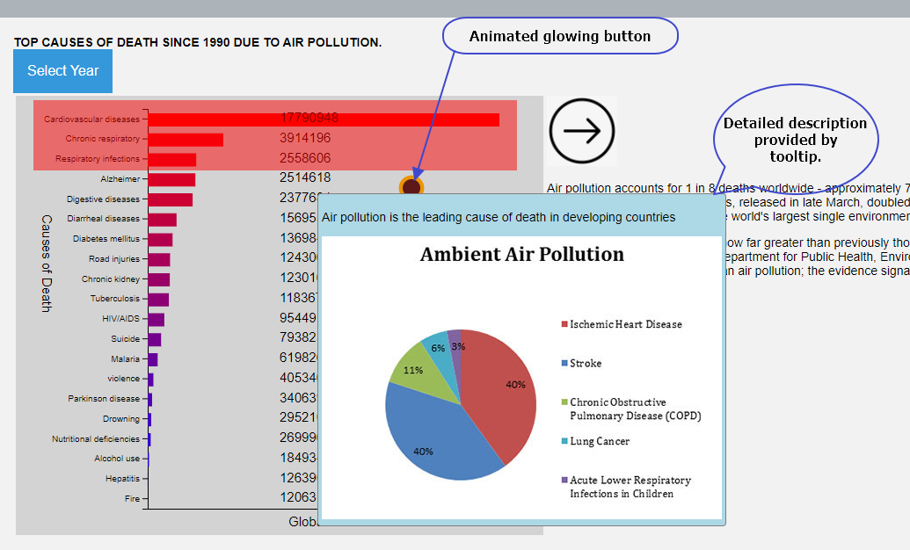

Figure 4 Detailed Annotation

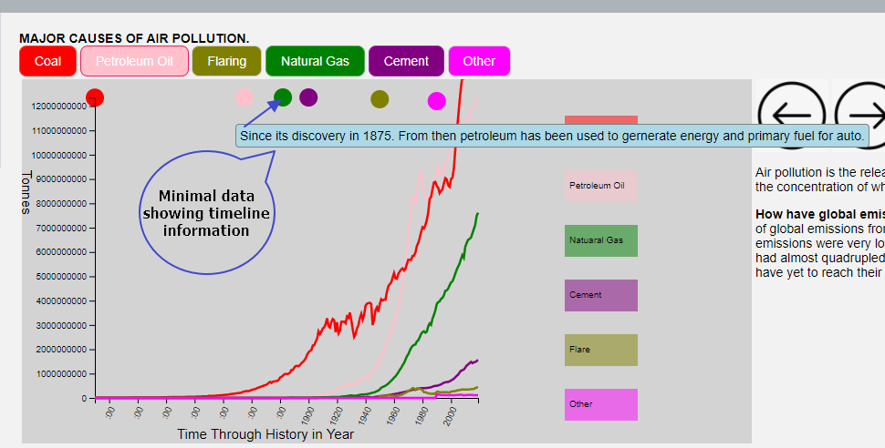

Figure 5Basic timeline annotation

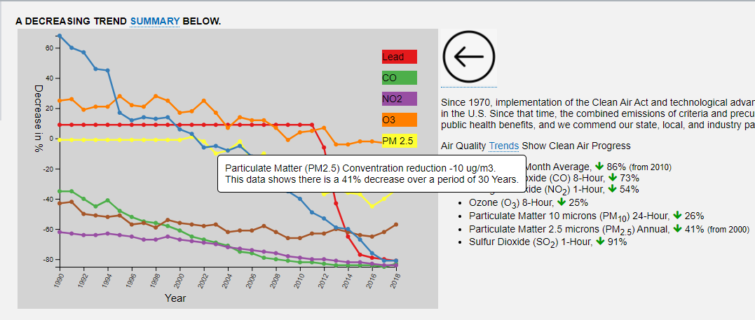

Figure 6 Annotations showing data related to research details

**Parameters:**

The opening scene has a capability for a user to choose a different year to know the mortality report. The parameter makes a filter to the csv data and refreshes the chart based on the selection. The author wants to ensure the reader is convinced that the top 3 death caused are due to air pollution.

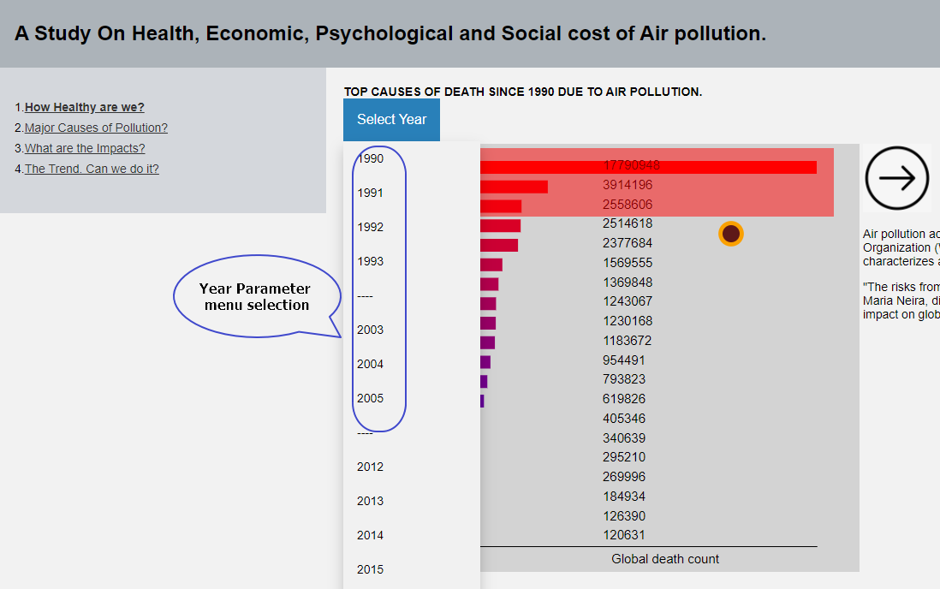

Figure 7 Year Parameter to filter data for a year

The parameter for the causes of pollution applies selective filters to cause of the pollution.

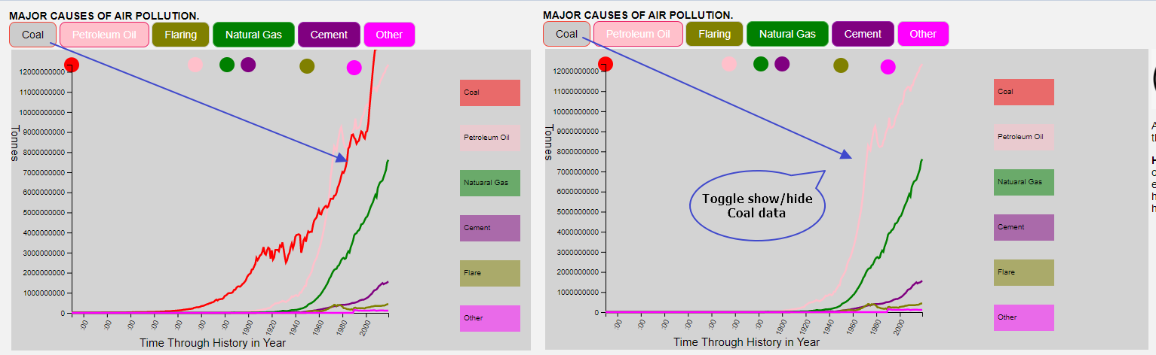

Figure 8 Toggle chart data

**Trigger:**

The affordance has been achieved using the d3.js animations to draw user attention. D3.js callback has been used to read and process the csv files.

All the scenes with chart has d3.csv callbacks. Various other button click and tooltip callback is also used. Additionally, a d3.js timer callback is used to give glowing button affect. Transition callbacks have been used to show the selected effect in scene 3

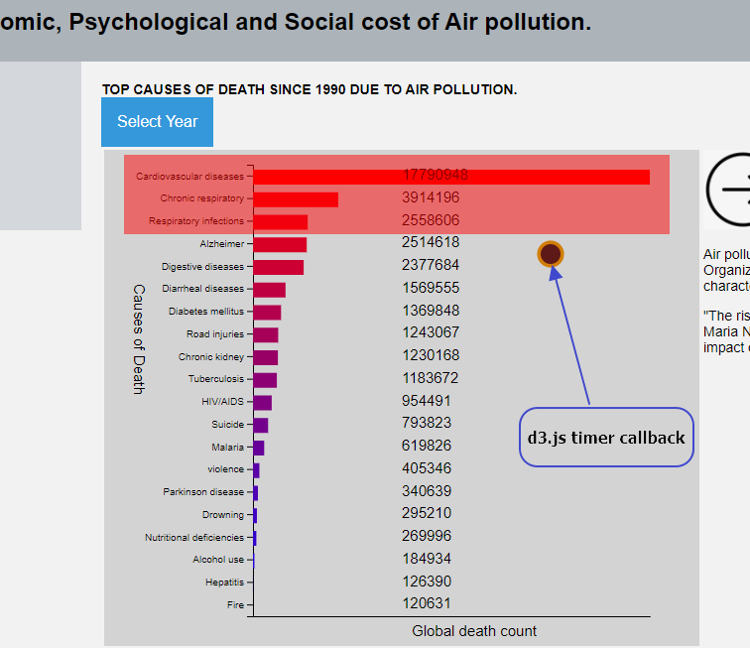

Figure 9 Timer callback

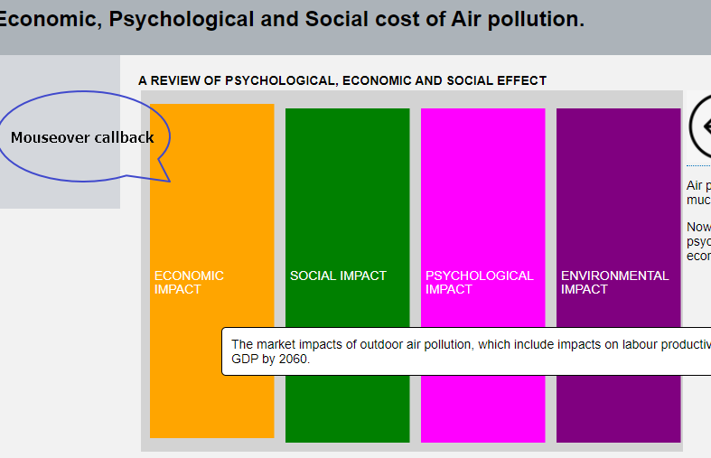

Figure 10 Mouseover callback